*vivo mobile*

vivo y17s

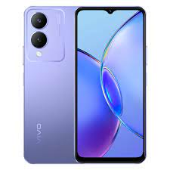

Display ; **Size. 6.56-inch ; Resolution. 1612 × 720** ; Refresh Rate. 60 Hz ; Local Peak Brightness. N/A ; Color Gamut. DCI-P3 not supported.

**PRICE / 36,999 PRK**